High_level_reg_1

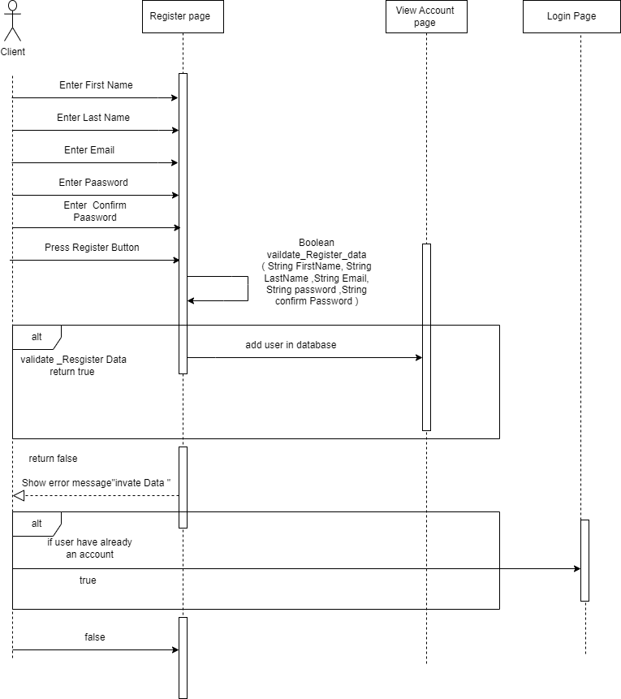

High_level_login_1

High_level_login_admin_1

